### **SPRINT 1**

Natural Disasters Intensity Analysis and Classification using Artificial Intelligence

**TEAM MEMBERS:**

412419104051-KAVANA RAO Y

412419104012-ARCHANA K

412419104128-SUDHARSHINY T A

412419104045-JOE MARIAM.J

412419104107-SAUJANYA K

**DATABASE COLLECTION AND DOWNLOAD:**

A data set (or dataset) is a collection of data. 499 MB of data was downloaded successfully and saved.

**CREATION OF IBM CLOUD ACCOUNT:**

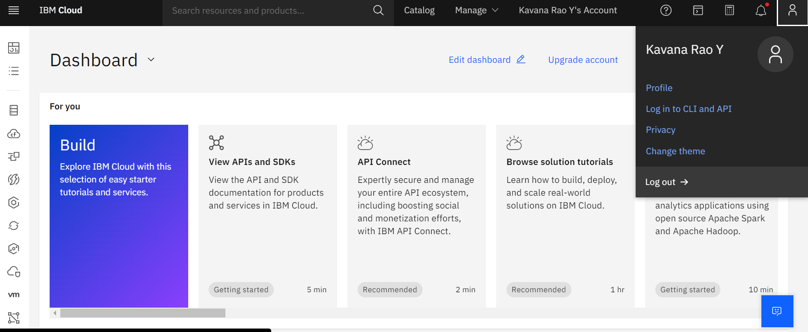

**WATSON STUDIO PROJECT CREATION:**

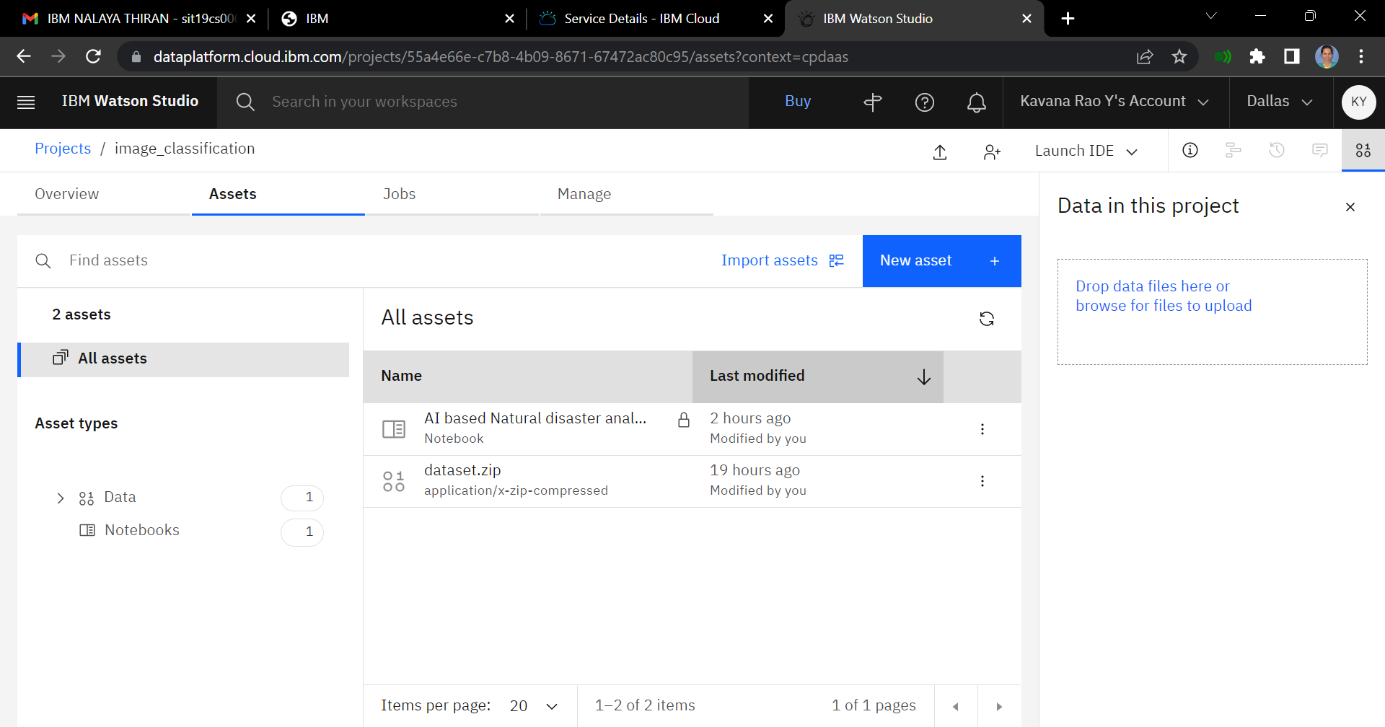

**CREATION OF DEPLOYMENT SPACE:**

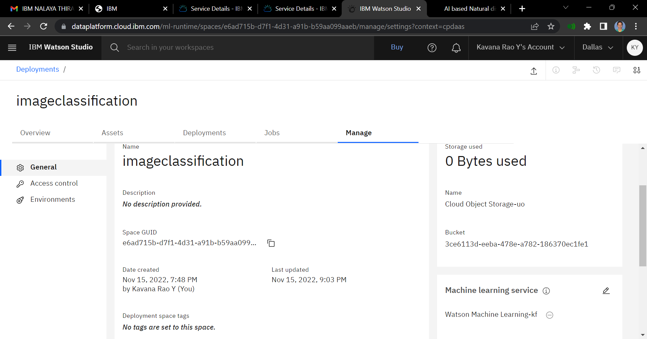

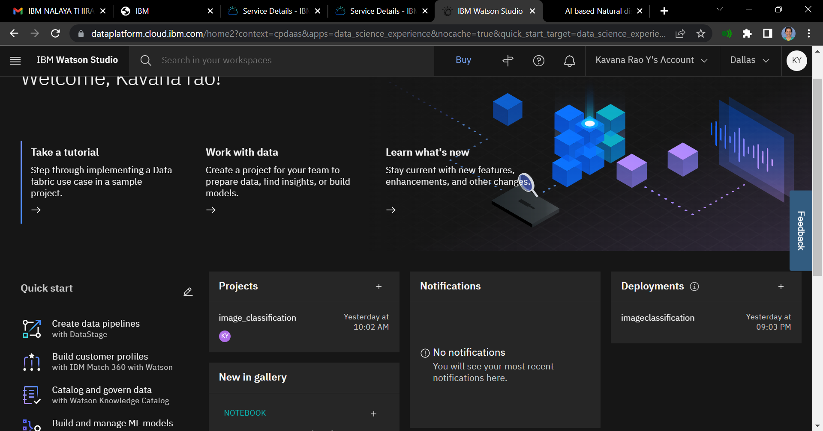

**TRAINING AND FITTING THE MODEL:**

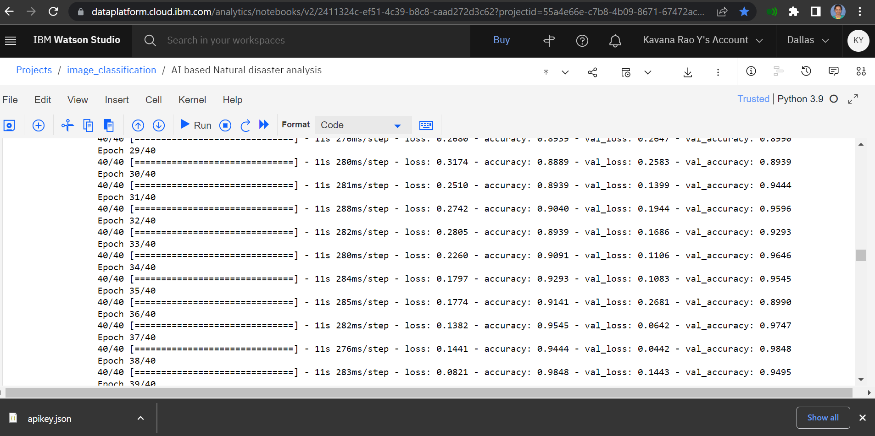

**SAVING THE MODEL:**

